## HostListener & HostBinding

**Learning Objectives**

* How to respond to output events that occur on the host element the directive is attached to.
* How to manipulate the host element by binding to it’s input properties.

**HostListener**

In the previous lecture we created our first directive, ccCardHover, which simply turned the background color gray for every element it’s attached to.

But as the name of the directive implies we need a way of *detecting* if the user is hovering over the host element.

Angular makes this easy with the @HostListener decorator.

This is a *function* decorator that accepts an *event name* as an argument. When that event gets fired on the *host* element it calls the associated function.

So if we add this function to our directive class:

@HostListener('mouseover') onHover() {

window.alert("hover");

}

Hovering over the host element would trigger an alert popup.

Lets change our directive to take advantage of the @HostListener.

import { HostListener } from '@angular/core'

.

.

.

class CardHoverDirective {

constructor(private el: ElementRef,

private renderer: Renderer) {

①

// renderer.setElementStyle(el.nativeElement, 'backgroundColor', 'gray');

}

@HostListener('mouseover') onMouseOver() {

②

let part = this.el.nativeElement.querySelector('.card-text')

③

this.renderer.setElementStyle(part, 'display', 'block');

④

}

}

1. We’ve removed the code to render the background color to gray.
2. We decorate a class method with @HostListener configuring it to call the function on every mouseover events.
3. We get a reference to the DOM element that holds the jokes punchline.
4. We set the display to block so that element is shown.

For the above to work we need to change our JokeComponent template so the joke is hidden using the display style property, like so:

<

div class="card card-block" ccCardHover

>

<h4 class="card-title">{{data.setup}}</h4>

<p class="card-text"

[style.display]="'none'">{{data.punchline}}</p>

①

②

<

/div

>

1. We change the p element so it’s hidden via a style of display: none, this is so we can *show* the element by setting the style to display: block.
2. We’ve also removed the button, so the only way to show the punchline is via hovering over the card.

As well as showing the punchline on a mouseover event we also want to *hide* the punchline on a mouse*out* event, like so:

class CardHoverDirective {

constructor(private el: ElementRef,

private renderer: Renderer) {

// renderer.setElementStyle(el.nativeElement, 'backgroundColor', 'gray');

}

@HostListener('mouseover') onMouseOver() {

let part = this.el.nativeElement.querySelector('.card-text');

this.renderer.setElementStyle(part, 'display', 'block');

}

@HostListener('mouseout') onMouseOut() {

let part = this.el.nativeElement.querySelector('.card-text');

this.renderer.setElementStyle(part, 'display', 'none');

}

}

Now when we hover over the card we show the joke and when we move out of the card the punchline is hidden again.

**HostBinding**

As well as listening to output events from the host element a directive can also bind to *input properties* in the host element with @HostBinding.

This directive can *change* the properties of the host element, such as the list of classes that are set on the host element as well as a number of other properties.

Using the @HostBinding decorator a directive can link an internal property to an input property on the host element. So if the internal property changed the input property on the host element would also change.

We first need something, a property on our directive which we can use as a source for binding.

We’ll create a boolean called ishovering and in our onMouseOver() and onMouseOut() functions we’ll set this to true and false accordingly, like so:

class CardHoverDirective { private ishovering: boolean; ①

constructor(private el: ElementRef,

private renderer: Renderer) {

}

@HostListener('mouseover') onMouseOver() {

let part = this.el.nativeElement.querySelector('.card-text');

this.renderer.setElementStyle(part, 'display', 'block');

this.ishovering = true; ②

}

@HostListener('mouseout') onMouseOut() {

let part = this.el.nativeElement.querySelector('.card-text');

this.renderer.setElementStyle(part, 'display', 'none');

this.ishovering = false; ②

}

}

1. We’ve created a boolean called ishovering.
2. We set our boolean to true when we are being hovered over and false when we are not.

Now we need to *link* this source property to an input property on the host element, we do this by decorating our ishovering boolean with the @HostBinding decorator.

The @HostBinding decorator takes one parameter, the name of the property on the host element which we want to bind to.

If you remember we can use the alternative ngClass syntax by binding to the [class.<class-name>] property. Lets add the card-outline-primary class to our host element when the ishovering boolean is true.

*script.ts*

import { HostBinding } from '@angular/core' .

. . class CardHoverDirective {

@HostBinding('class.card-outline-primary') private ishovering: boolean; ①

constructor(private el: ElementRef,

private renderer: Renderer) {

// renderer.setElementStyle(el.nativeElement, 'backgroundColor', 'gray');

}

@HostListener('mouseover') onMouseOver() {

let part = this.el.nativeElement.querySelector('.card-text');

this.renderer.setElementStyle(part, 'display', 'block');

this.ishovering = true;

}

@HostListener('mouseout') onMouseOut() {

let part = this.el.nativeElement.querySelector('.card-text');

this.renderer.setElementStyle(part, 'display', 'none');

this.ishovering = false;

}

}

① We’ve added the @HostBinding decorator to the ishovering property.

Now when we hover over a card as well as the punchline showing we adding a blue border to the card, like so:

**Summary**

By using the @HostListener and @HostBinding decorators we can both listen to output events from our host element and also bind to input properties on our host element as well.

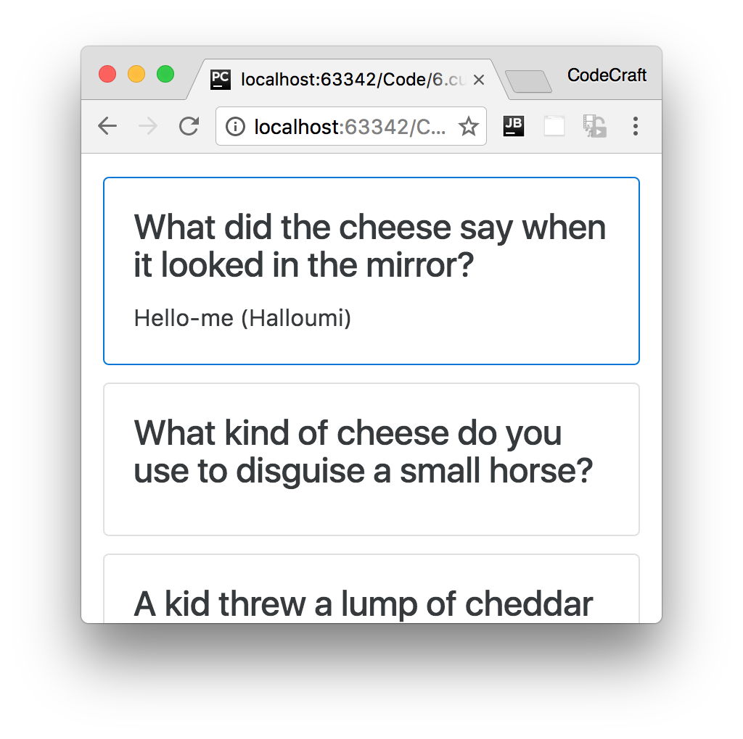In the next lecture we will cover how to provide inputs and configuration to our directives so they can be easily re-used.

**Listing**

<http://plnkr.co/edit/EgsmbXMN7s7YYDYIu9N8?p=preview>

*script.ts*

import {platformBrowserDynamic} from '@angular/platform-browser-dynamic';

import {

Component,

Directive,

Renderer,

HostListener,

HostBinding,

ElementRef,

NgModule,

Input,

Output,

EventEmitter

}

from '@angular/core';

import {BrowserModule} from '@angular/platform-browser';

class Joke {

public setup: string;

public punchline: string;

public hide: boolean;

constructor(setup: string, punchline: string) {

this.setup = setup;

this.punchline = punchline;

this.hide = true;

}

toggle() {

this.hide = !this.hide;

}

}

@Directive({

selector: "[ccCardHover]"

})

class CardHoverDirective {

@HostBinding('class.card-outline-primary')private ishovering: boolean;

constructor(private el: ElementRef,

private renderer: Renderer) {

// renderer.setElementStyle(el.nativeElement, 'backgroundColor', 'gray');

}

@HostListener('mouseover') onMouseOver() {

let part = this.el.nativeElement.querySelector('.card-text');

this.renderer.setElementStyle(part, 'display', 'block');

this.ishovering = true;

}

@HostListener('mouseout') onMouseOut() {

let part = this.el.nativeElement.querySelector('.card-text');

this.renderer.setElementStyle(part, 'display', 'none');

this.ishovering = false;

}

}

@Component({

selector: 'joke',

template: `

<

div class="card card-block" ccCardHover

>

<h4 class="card-title">{{data.setup}}</h4>

<p class="card-text"

[style.display]="'none'">{{data.punchline}}</p>

<

/div

>

`

})

class JokeComponent {

@Input('joke') data: Joke;

}

@Component({

selector: 'joke-list',

template: `

<

joke *ngFor="let j of jokes" [joke]="j"></joke

>

`

})

class JokeListComponent {

jokes: Joke[];

constructor() {

this.jokes = [

new Joke("What did the cheese say when it looked in the mirror?", "Hello-me

(

Halloumi)"),

new Joke("What kind of cheese do you use to disguise a small horse?", "Mask-a-

pony (Mascarpone)"),

new Joke("A kid threw a lump of cheddar at me", "I thought

‘

That

’

s not very

mature

’

"),

];

}

}

@Component({

selector: 'app',

template: `

<

joke-list></joke-list

>

`

})

class AppComponent {

}

@NgModule({

imports: [BrowserModule],

declarations: [

AppComponent,

JokeComponent,

JokeListComponent,

CardHoverDirective

],

bootstrap: [AppComponent]

})

export class AppModule {

}

platformBrowserDynamic().bootstrapModule(AppModule);